**Table of Contents**

**Chapter Particulars Page No.**

1. Introduction……………………………………………………………..
2. Technologies used………………………………………………………
3. Modules………………………………………………………................
4. Website snapshots………………………………………………………
5. GitHub link link………………………...................................................

References……………………………………………………………………………

**Marks distribution**

**Report + UMS report upload** - 10 Marks (Follow the report format)

**Github Project Upload** -5 Marks

**Project developed + Myclass presentation** -15

**NOTE:**

1. **0 marks will be awarded if the project submitted is different from the one that was communicated previously.**
2. **0 marks will be awarded if report is not uploaded on UMS or presentation not conducted on myclass**



**Project Report**

**on**

**News Website**

Submitted to

**LOVELY PROFESSIONAL UNIVERSITY**

for

**Bachelor of Computer Science and Engineering**

**Submitted By Submitted to**

**Abhishek Gupta Navneet Kaur**

**11908904 Assistant Professor**

**LOVELY FACULTY OF TECHNOLOGY & SCIENCES**

**LOVELY PROFESSIONAL UNIVERSITY**

**PUNJAB**

**November 2021**

**CHAPTER 1**

**INTRODUCTION**

* 1. **Introduction**

My project is based on a News website named: “The News” (Fig 1.1).

* + 1. **About website**

"The News" will serve as a trusted guide to the crush of news and ideas around you. With thoughtful analysis and fearless views. We will track news locally in Sikkim as well as in India and the world and provide a perspective that is reflective of a changing dynamic

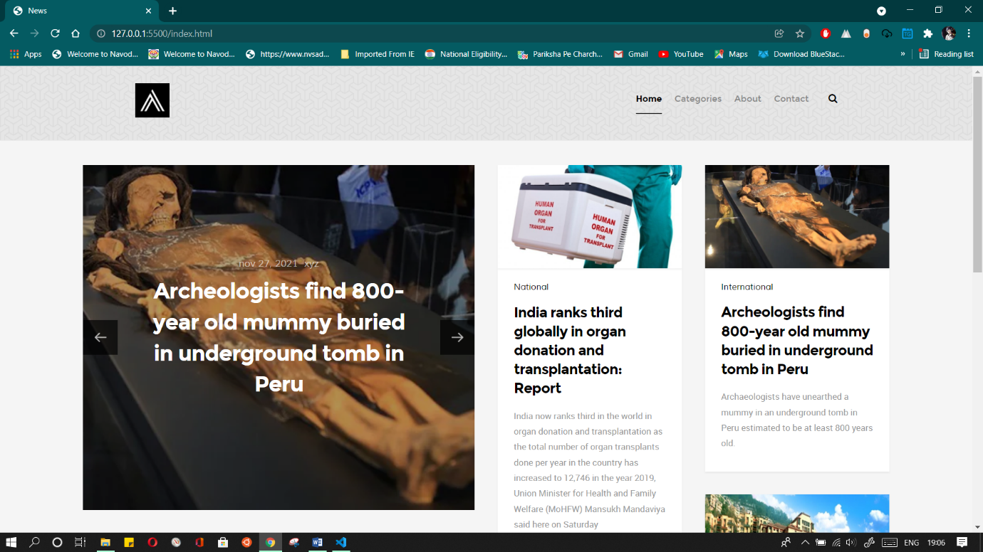

**Figure 1.1**

* 1. **Technology used**
     1. **Html5**
     2. **Css3**
     3. **JavaScript**
     4. **Visual studio**

.

**3.1 Modules**

**3.1.1 Index**

**3.1.2 about**

**3.1.3 National**

**3.1.4 International**

**3.1.5 Sikkim**

**3.1.6 Contact**

**3.1.7 post1**

**3.1.8 post2**

**3.1.9 post3**

**4.1 Website Snapshots**

**4.1.1 Homepage (Figure 4.1.1)**

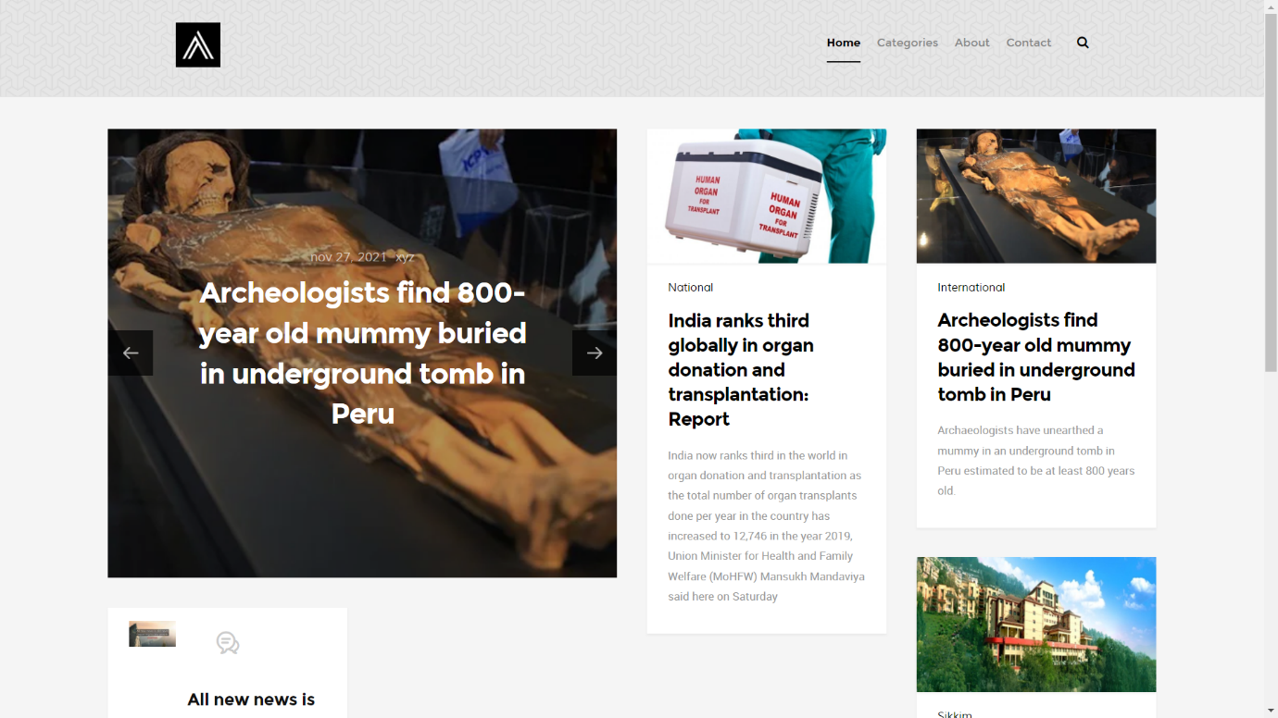

**Figure 4.1.1**

**4.1.2 Category**

**4.1.2.1 National (Figure 4.1.2.1)**

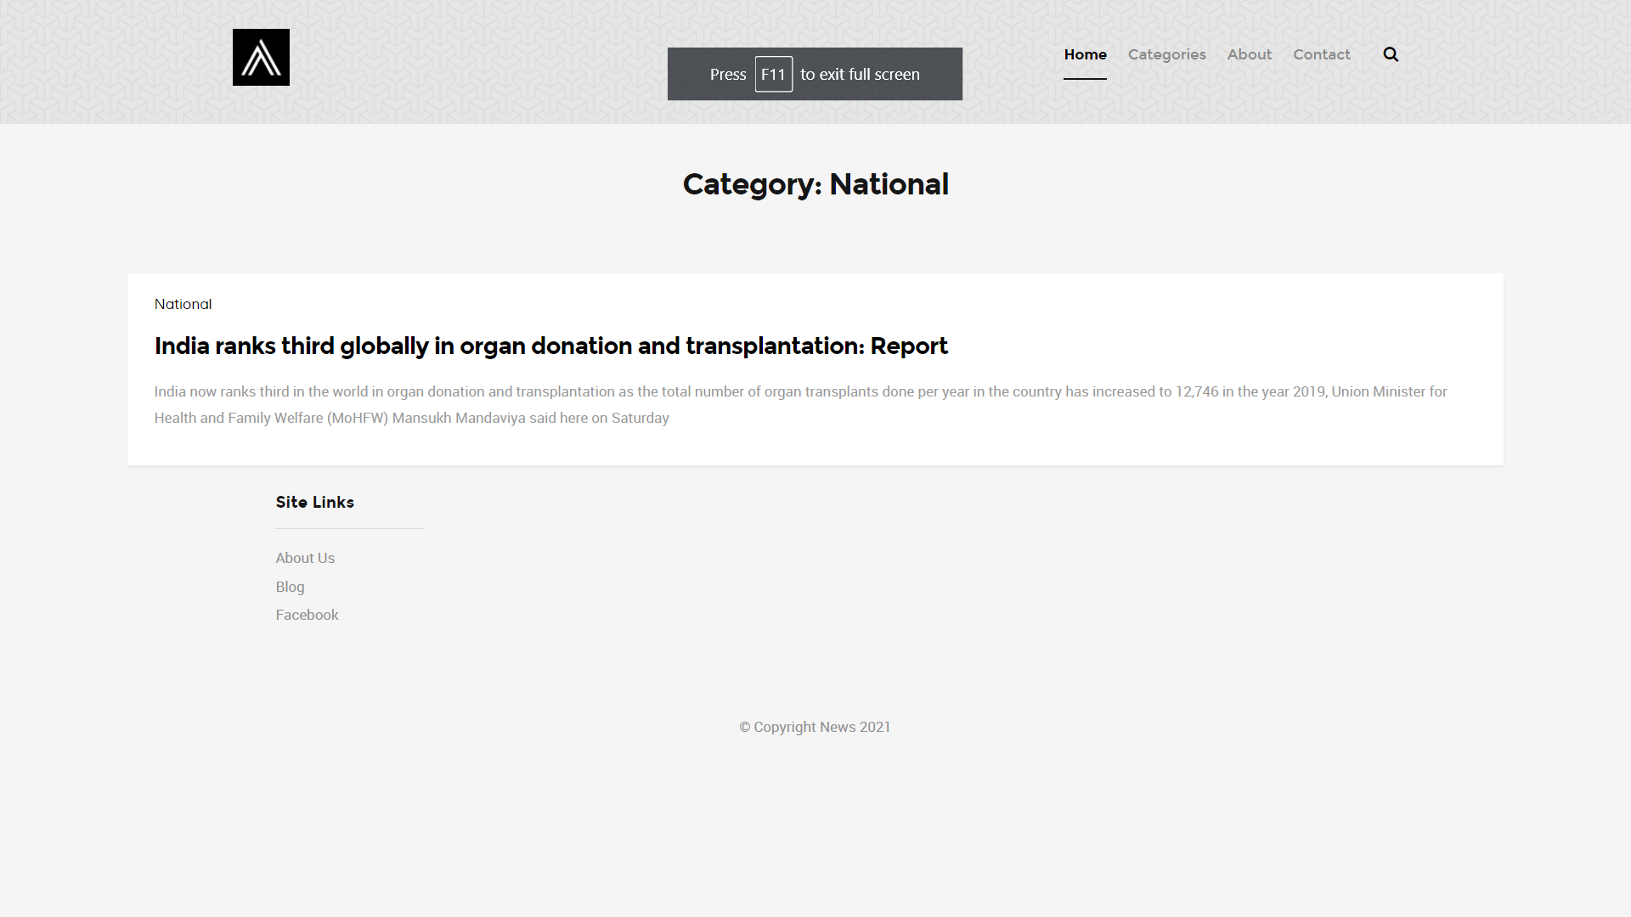

**Figure 4.1.2.1**

**4.1.2.2 International (Figure 4.1.2.2)**

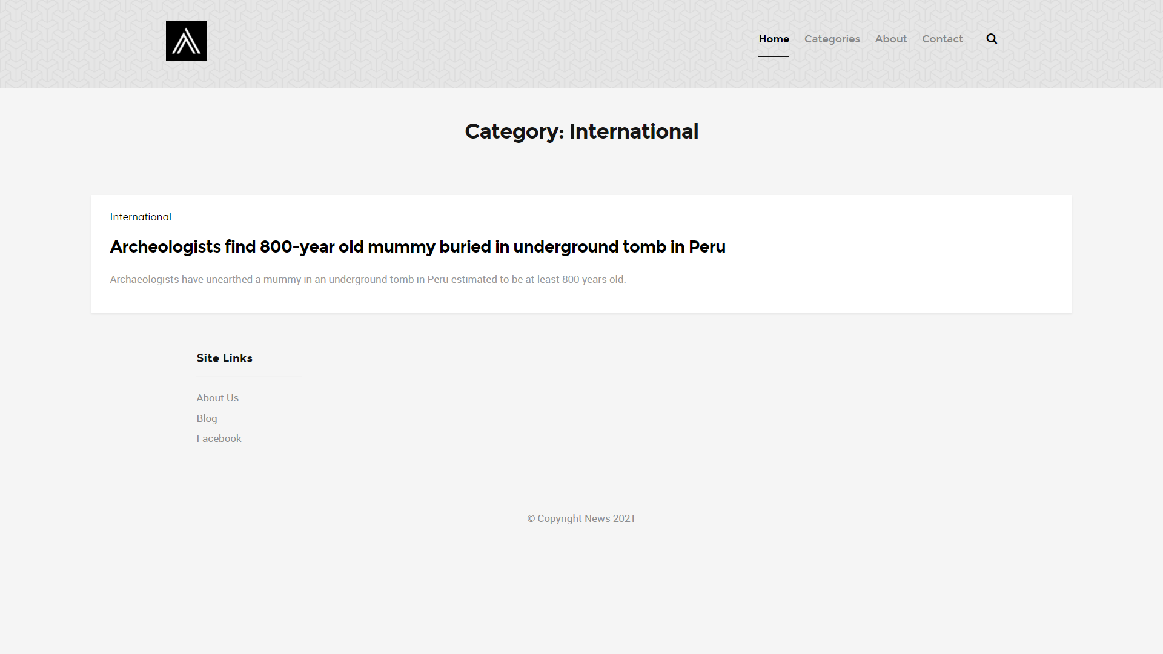

**Figure 4.1.2.2**

**4.1.2.3 Sikkim (Figure 4.1.2.3)**

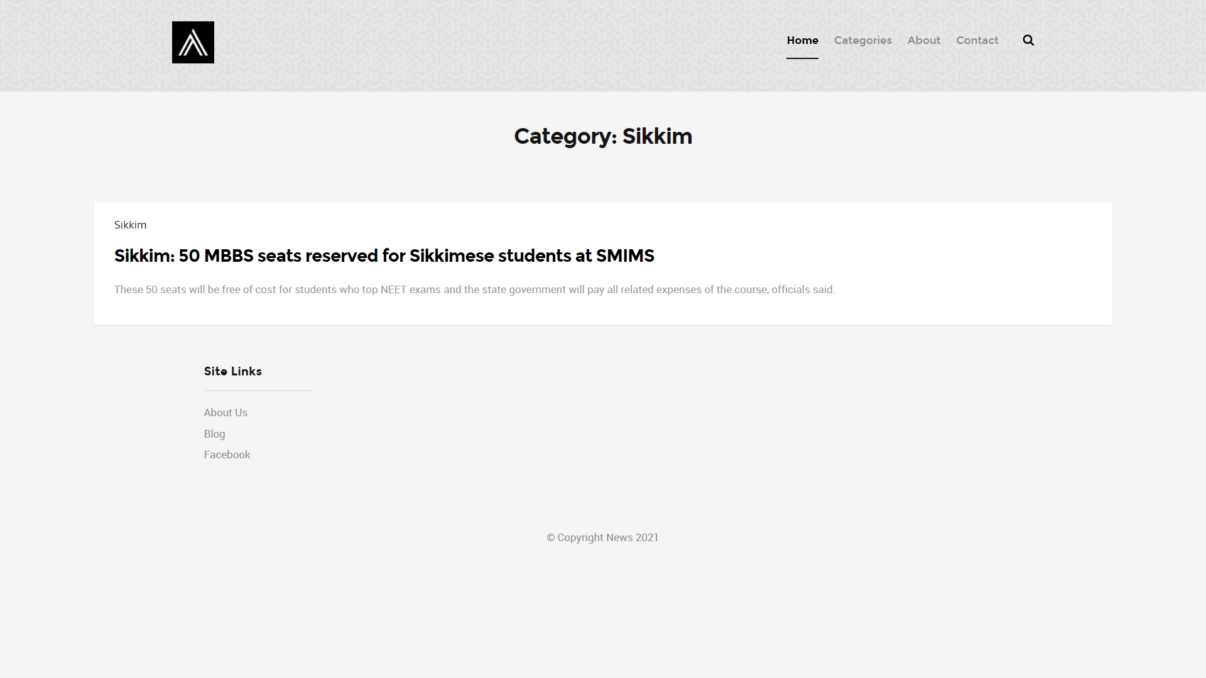

**Figure 4.1.2.3**

**4.1.3 About (Figure 4.1.3)**

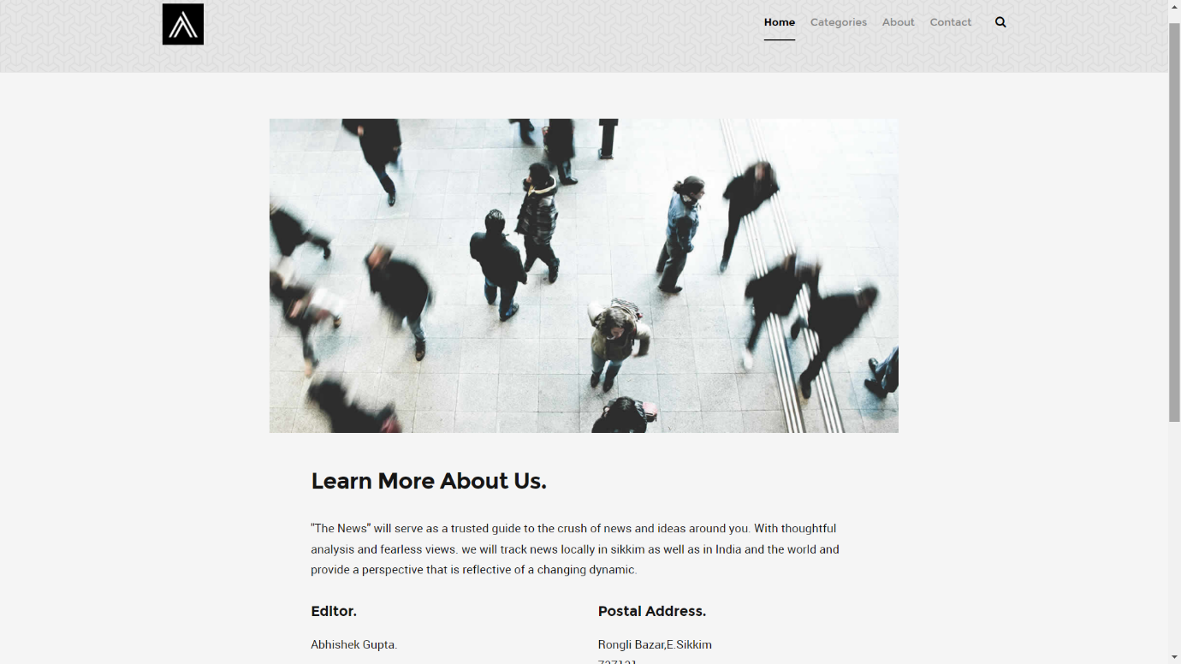

**Figure 4.1.3**

**4.1.4 Contact (Figure 4.1.4)**

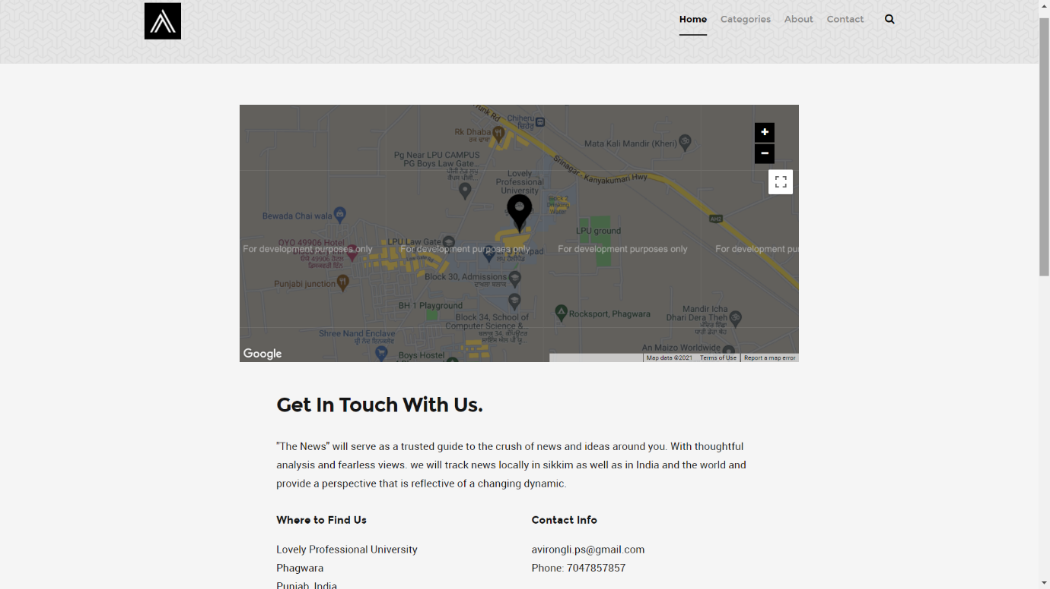

**Figure 4.1.4**

**4.1.5 Search (Figure 4.1.5)**

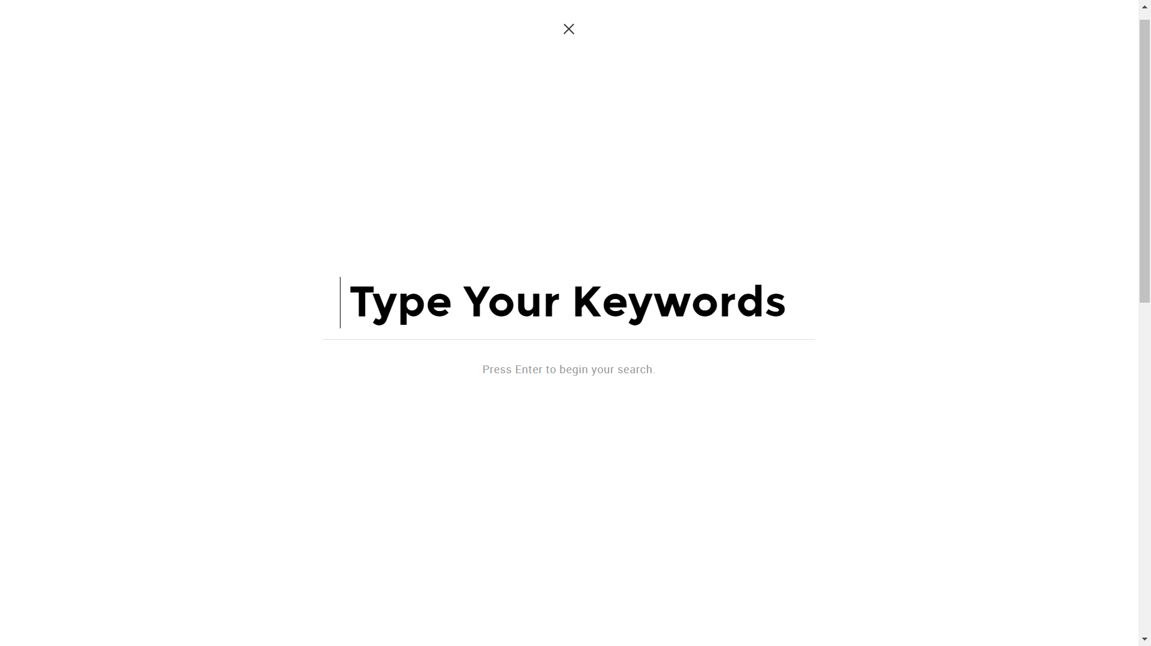

**Figure 4.1.5**

**4.1.6 Post1 (Figure 4.1.6)**

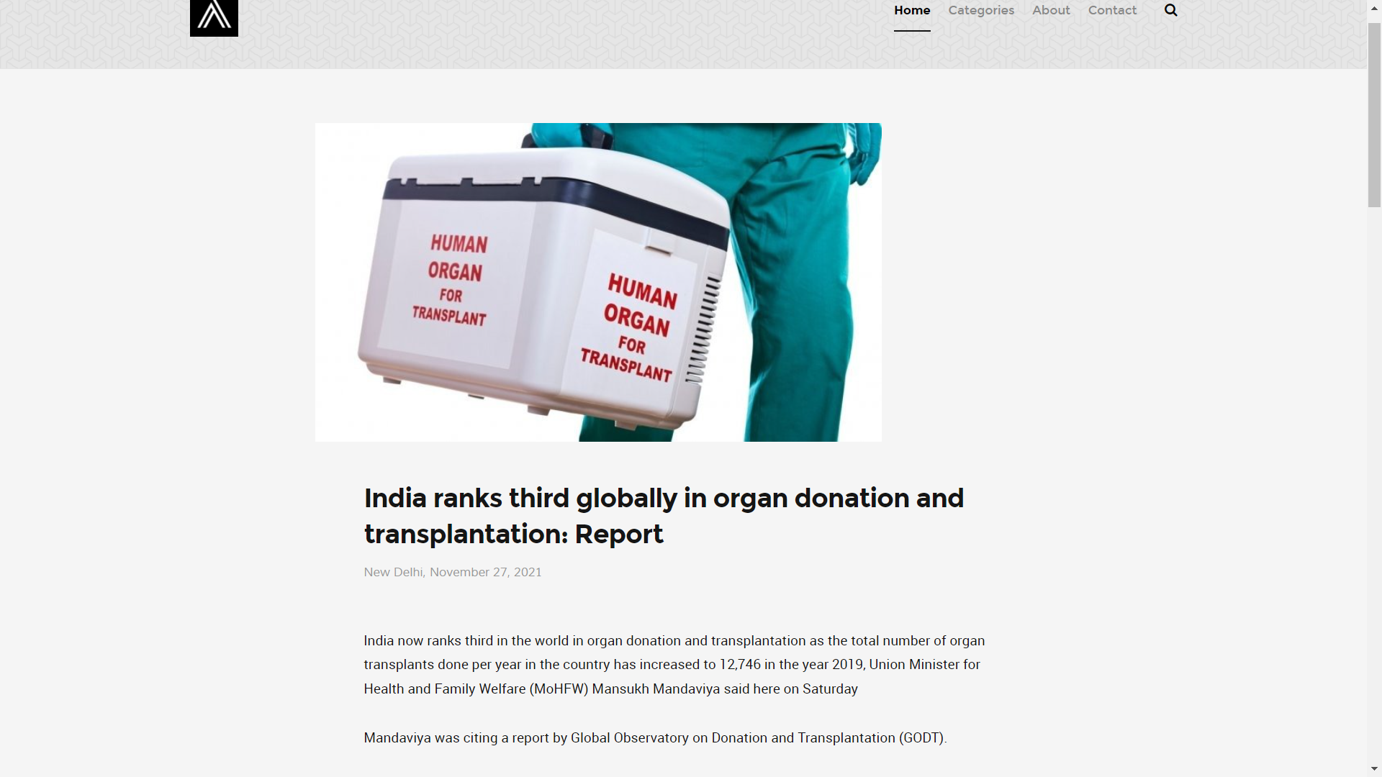

**Figure 4.1.6**

**4.1.7 Post2 (Figure 4.1.7)**

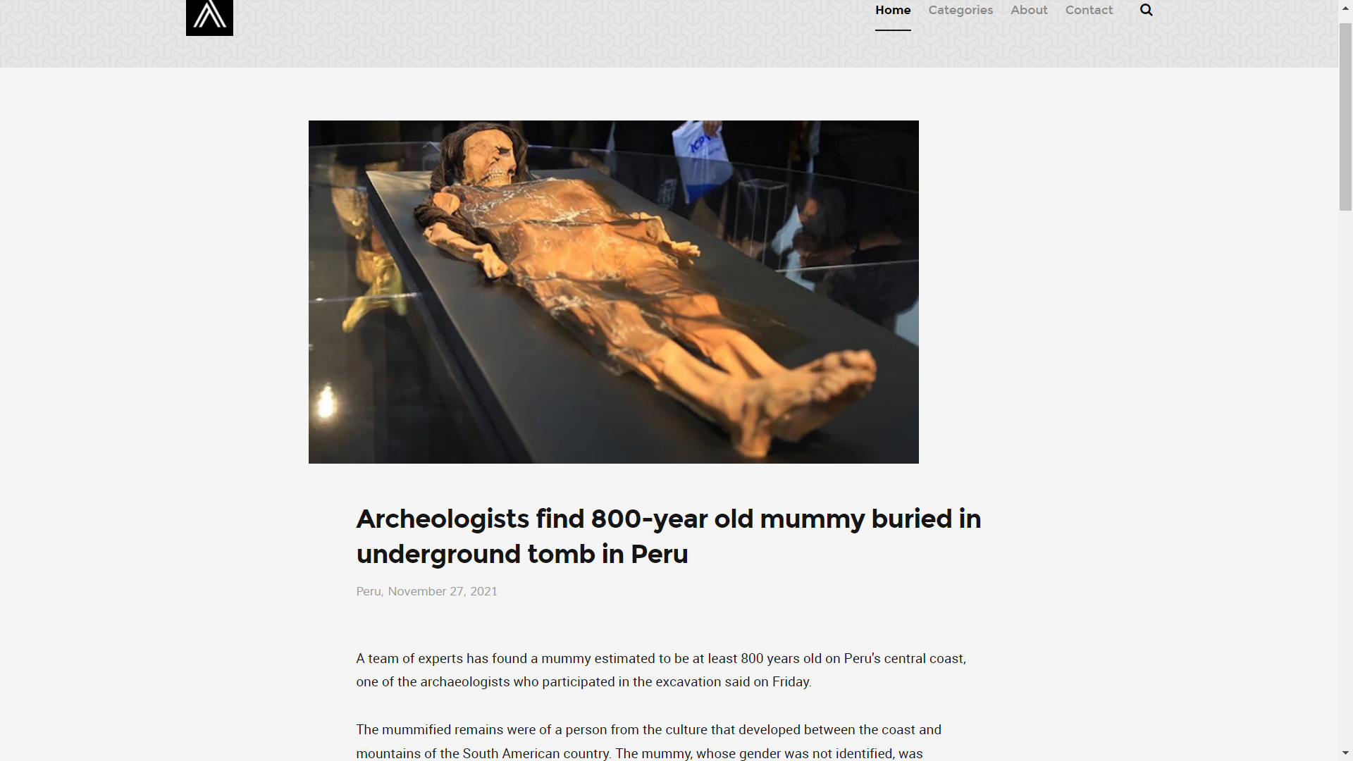

**Figure 4.1.7**

**4.1.8 Post3 (Figure 4.1.8)**

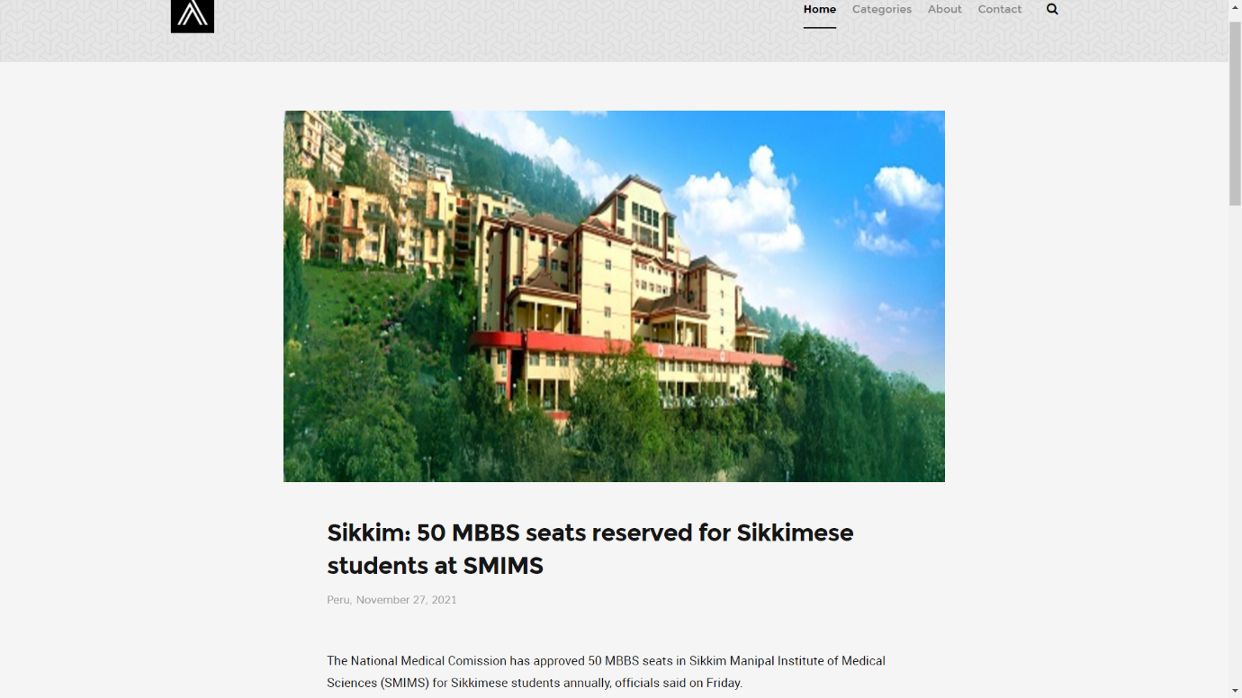

**Figure 4.1.8**

|  |
| --- |
|  |